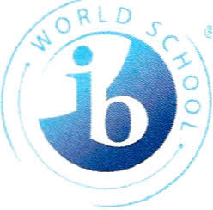

November 18, 2022

Greetings Langford Stakeholders,

As the Principal of Langford Middle School, it is indeed a pleasure to serve you, your child, and your family. Langford is comprised of a very dedicated, caring staff who serve our students with the best versions of themselves each and every day. Many teachers and support staff have been serving the Langford community for over ten years. This type of tenure, represented among our staff, speaks to their level of commitment toward our students.

The middle years of a child’s life can be very rewarding, but also quite confusing. This is a time where adolescents experience several transitions in relation to mental health, development, physical growth, and wellness. Furthermore, middle school children are beginning to make more advanced cognitive connections between school and the global environment. Here at Langford Middle School we are very committed to ensuring that we not only take care of each child, but also understand their unique needs.

As an International Baccalaureate school that infuses AVID strategies throughout the teaching and learning process, our aim is to ensure that students are aptly prepared for high school at the conclusion of matriculating. Additionally, it is important to note that the Langford Athletic program is amongst the top in the county and region as compared to other middle schools with similar demographics. There is an art, program, class, club, or sport that will cater to the needs and interests of every student.

Finally, we are here to serve and support you and your family. If there is ever a need for clarity or questions are unanswered, please reach out to us, and we will be happy to communicate with you in the most effective way possible.

Sincerely,

LaQuanda Carpenter, Ed.D.